Remote Access Instructions
  - NOTE: This is for Windows PCs only
These instructions show how Staff and Pupils to access their Ferndale Shared Drives, SIMS, and other resources.
It is highly recommended that you use Google Classroom or Google Drive for handing out work for Pupils.
- Navigate to the Ferndale website https://www.ferndalecs.com/
- Click on Remote Access in the top menu.
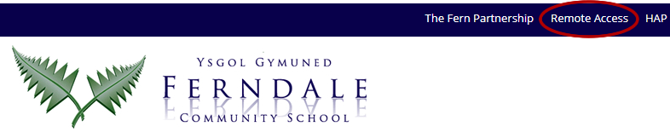
- Log in with your school email address and password.
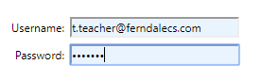
- You will be presented with a grid of applications available. The main ones are the following:
  - My Computer – Access all your shared drives. Open & save files exactly the same as in school.
  - SIMS
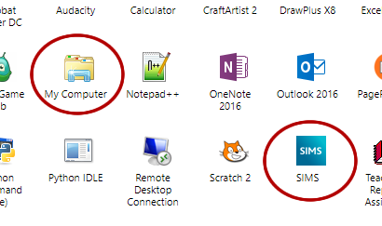
- Click My Computer, and an RDP file will download.
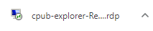
- Click the downloaded file.
- You will be prompted a logon window. Now click More choices.
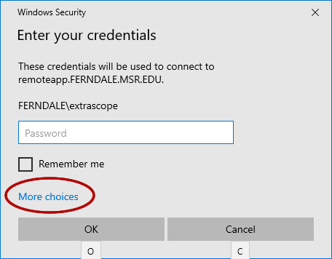
Then click Use a different account.
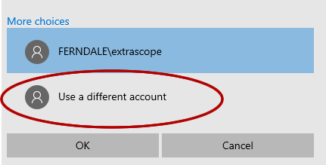
- Now login with your school email address and password.
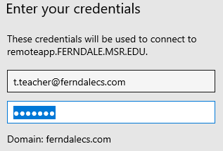
- Click Yes to accept the certificate.
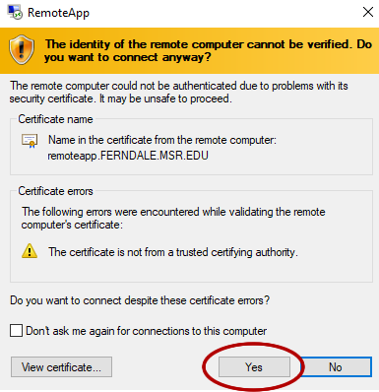
- Now you have access to all your shared network drives.
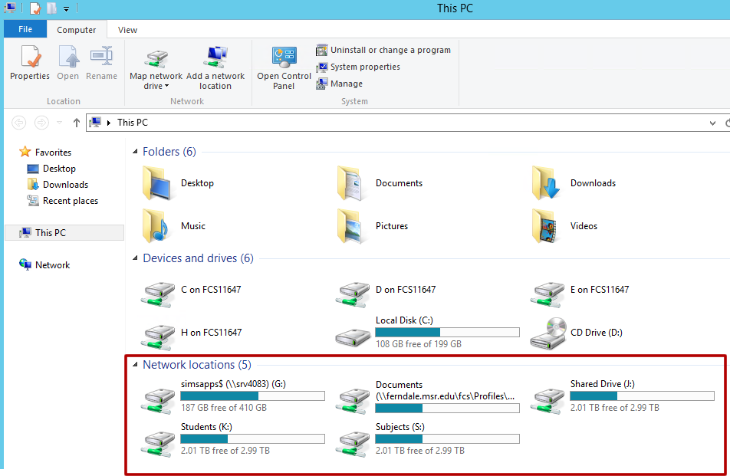
Notes:
- This is not guaranteed to work on Mac computers.
- If your session disconnects due to high demand, don’t panic because the next time you connect, your session would have saved.
Tips:
- Once you’ve downloaded the RDP(s) file in step 5, you can copy it from your Downloads folder to your desktop and rename it ‘Work Files’ (as an example). That way instead of going through the website, you can just double-click the ‘Work Files’ file, and log in.

